3. Demonstrate the working of the decision tree based ID3 algorithm. Use an appropriate data set for building the decision tree and apply this knowledge to classify a new sample.
Procedure
- Import the Decision Tree Classifier.
- Create the training dataset and target values.
- Create the Decision Tree model using entropy.
- Train the model using the training data.
- Classify a new sample using the trained model.
- Display the predicted result.

Dataset 1: Play Tennis
Outlook | Temperature | Humidity | Wind | Play Tennis
Sunny | Hot | High | Weak | No
Sunny | Hot | High | Strong | No
Overcast | Hot | High | Weak | Yes
Rain | Mild | High | Weak | Yes
Rain | Cool | Normal | Weak | Yes
Rain | Cool | Normal | Strong | No
Overcast | Cool | Normal | Strong | Yes
Sunny | Mild | High | Weak | No
Sunny | Cool | Normal | Weak | Yes
Rain | Mild | Normal | Weak | Yes
Sunny | Mild | Normal | Strong | Yes
Overcast | Mild | High | Strong | Yes
Overcast | Hot | Normal | Weak | Yes
Rain | Mild | High | Strong | No
Target Variable: Play Tennis (Yes/No)

Coding
# ID3 Decision Tree - Play Tennis
# No sklearn required

import math

# Training Dataset
data = [
['Sunny', 'Hot', 'High', 'Weak', 'No'],
['Sunny', 'Hot', 'High', 'Strong', 'No'],
['Overcast', 'Hot', 'High', 'Weak', 'Yes'],
['Rain', 'Mild', 'High', 'Weak', 'Yes'],
['Rain', 'Cool', 'Normal', 'Weak', 'Yes'],
['Rain', 'Cool', 'Normal', 'Strong', 'No'],
['Overcast', 'Cool', 'Normal', 'Strong', 'Yes'],
['Sunny', 'Mild', 'High', 'Weak', 'No'],
['Sunny', 'Cool', 'Normal', 'Weak', 'Yes'],
['Rain', 'Mild', 'Normal', 'Weak', 'Yes'],
['Sunny', 'Mild', 'Normal', 'Strong', 'Yes'],
['Overcast', 'Mild', 'High', 'Strong', 'Yes'],
['Overcast', 'Hot', 'Normal', 'Weak', 'Yes'],
['Rain', 'Mild', 'High', 'Strong', 'No']
]

features = ['Outlook', 'Temperature', 'Humidity', 'Wind']

# Calculate entropy
def entropy(rows):

total = len(rows)

yes = sum(1 for row in rows if row[-1] == 'Yes')
no = total - yes

result = 0

for count in [yes, no]:
if count > 0:
p = count / total
result -= p * math.log2(p)

return result

# Information Gain
def information_gain(rows, index):

total_entropy = entropy(rows)

values = set(row[index] for row in rows)

weighted_entropy = 0

for value in values:

subset = [
row for row in rows
if row[index] == value
]

weighted_entropy += (
len(subset) / len(rows)
) * entropy(subset)

return total_entropy - weighted_entropy

# Find best attribute
def best_attribute(rows, available_features):

gains = []

for index in available_features:
gains.append(
(information_gain(rows, index), index)
)

return max(gains)[1]

# Build ID3 tree
def build_tree(rows, available_features):

labels = [row[-1] for row in rows]

# All examples have same class
if labels.count(labels[0]) == len(labels):
return labels[0]

# No attributes left
if not available_features:
return max(set(labels), key=labels.count)

best = best_attribute(rows, available_features)

tree = {
features[best]: {}
}

values = set(row[best] for row in rows)

remaining = [
i for i in available_features
if i != best
]

for value in values:

subset = [
row for row in rows
if row[best] == value
]

tree[features[best]][value] = build_tree(
subset,
remaining
)

return tree

# Build Decision Tree
tree = build_tree(
data,
list(range(len(features)))
)

print("Decision Tree:")
print(tree)

# Prediction function
def predict(tree, sample):

if not isinstance(tree, dict):
return tree

attribute = list(tree.keys())[0]

index = features.index(attribute)

value = sample[index]

branch = tree[attribute]

if value in branch:
return predict(branch[value], sample)

return "Unknown"

# New Sample
new_sample = [
'Sunny',
'Cool',
'High',
'Weak'
]

prediction = predict(tree, new_sample)

print("\nNew Sample:")
print(new_sample)

print("\nPredicted Result:")
print(prediction)

Output:
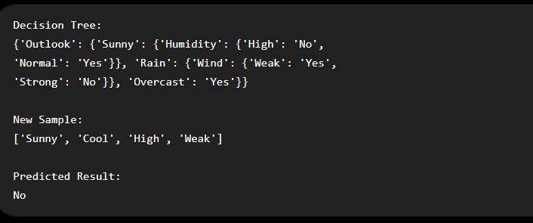
Dataset 2: Student Placement
CGPA | Communication | Internship | Programming | Placement
High | Good | Yes | Good | Yes
High | Excellent | Yes | Excellent | Yes
Medium | Good | Yes | Good | Yes
Medium | Average | No | Average | No
Low | Poor | No | Poor | No
High | Good | No | Good | Yes
Low | Average | No | Average | No
Medium | Good | Yes | Excellent | Yes
High | Excellent | Yes | Good | Yes
Low | Poor | Yes | Average | No
Target Variable: Placement
Coding:
# ============================================================
# ID3 Decision Tree - Student Placement
# Pure Python Version
# No sklearn required
# ============================================================

import math

# ------------------------------------------------------------
# Training Dataset
# ------------------------------------------------------------

X = [
['High', 'Good', 'Yes', 'Good'],
['High', 'Excellent', 'Yes', 'Excellent'],
['Medium', 'Good', 'Yes', 'Yes'],
['Good', 'Yes', 'Medium', 'Yes'],
['Medium', 'Average', 'No', 'No'],
['Average', 'No', 'Low', 'No'],
['Low', 'Poor', 'No', 'Poor'],
['Poor', 'No', 'High', 'No'],
['High', 'Good', 'Yes', 'No'],
['Good', 'Yes', 'Low', 'Average'],
['Low', 'Average', 'No', 'No'],
['Average', 'No', 'Medium', 'Good'],
['Medium', 'Good', 'Yes', 'Excellent'],
['High', 'Excellent', 'Yes', 'Good'],
['Good', 'Yes', 'Low', 'Poor'],
['Low', 'Poor', 'No', 'Average']
]

# Target values
y = [
'Yes', 'Yes', 'Yes', 'Yes',
'No', 'No', 'No', 'No',
'No', 'Yes', 'No', 'No',
'Yes', 'Yes', 'Yes', 'No'
]

# Feature names
features = [
'CGPA',
'Communication',
'Internship',
'Programming'
]

# ------------------------------------------------------------
# Combine X and y
# ------------------------------------------------------------

data = []

for i in range(len(X)):
data.append(X[i] + [y[i]])

# ------------------------------------------------------------
# Entropy Function
# ------------------------------------------------------------

def entropy(rows):

total = len(rows)

yes_count = 0
no_count = 0

for row in rows:

if row[-1] == 'Yes':
yes_count += 1
else:
no_count += 1

entropy_value = 0

if yes_count > 0:
p_yes = yes_count / total
entropy_value -= p_yes * math.log2(p_yes)

if no_count > 0:
p_no = no_count / total
entropy_value -= p_no * math.log2(p_no)

return entropy_value

# ------------------------------------------------------------
# Information Gain Function
# ------------------------------------------------------------

def information_gain(rows, feature_index):

total_entropy = entropy(rows)

values = set()

for row in rows:
values.add(row[feature_index])

weighted_entropy = 0

for value in values:

subset = []

for row in rows:

if row[feature_index] == value:
subset.append(row)

weight = len(subset) / len(rows)

weighted_entropy += weight * entropy(subset)

return total_entropy - weighted_entropy

# ------------------------------------------------------------
# Find Best Attribute
# ------------------------------------------------------------

def find_best_attribute(rows, available_features):

best_feature = available_features[0]
best_gain = information_gain(
rows,
best_feature
)

for feature in available_features[1:]:

gain = information_gain(
rows,
feature
)

if gain > best_gain:

best_gain = gain
best_feature = feature

return best_feature

# ------------------------------------------------------------
# Build ID3 Decision Tree
# ------------------------------------------------------------

def build_tree(rows, available_features):

labels = []

for row in rows:
labels.append(row[-1])

# All are Yes
if labels.count('Yes') == len(labels):
return 'Yes'

# All are No
if labels.count('No') == len(labels):
return 'No'

# No attributes remaining
if len(available_features) == 0:

if labels.count('Yes') >= labels.count('No'):
return 'Yes'
else:
return 'No'

# Find best attribute
best_feature = find_best_attribute(
rows,
available_features
)

tree = {}

tree[features[best_feature]] = {}

# Find values of best attribute
values = set()

for row in rows:
values.add(row[best_feature])

# Remove selected attribute
remaining_features = []

for feature in available_features:

if feature != best_feature:
remaining_features.append(feature)

# Create branches
for value in values:

subset = []

for row in rows:

if row[best_feature] == value:
subset.append(row)

tree[features[best_feature]][value] = build_tree(
subset,
remaining_features
)

return tree

# ------------------------------------------------------------
# Build the Tree
# ------------------------------------------------------------

available_features = [0, 1, 2, 3]

tree = build_tree(
data,
available_features
)

# ------------------------------------------------------------
# Prediction Function
# ------------------------------------------------------------

def predict(tree, sample):

# If result is Yes or No
if not isinstance(tree, dict):
return tree

# Get attribute
attribute = list(tree.keys())[0]

# Get feature index
feature_index = features.index(attribute)

# Get sample value
value = sample[feature_index]

# Get branches
branches = tree[attribute]

# Follow branch
if value in branches:

return predict(
branches[value],
sample
)

return "Unknown"

# ------------------------------------------------------------
# New Sample
# ------------------------------------------------------------

new_sample = [
'High',
'Good',
'Yes',
'Excellent'
]

# ------------------------------------------------------------
# Prediction
# ------------------------------------------------------------

prediction = predict(
tree,
new_sample
)

# ------------------------------------------------------------
# Display Output
# ------------------------------------------------------------
print("========================================")
print(" ID3 DECISION TREE")
print(" STUDENT PLACEMENT")
print("========================================")
print("\nNew Sample:")
print("CGPA :", new_sample[0])
print("Communication :", new_sample[1])
print("Internship :", new_sample[2])
print("Programming :", new_sample[3])
print("\nDecision Tree:")
print(tree)
print("\nPredicted Placement:", prediction)
print("========================================")
Output:
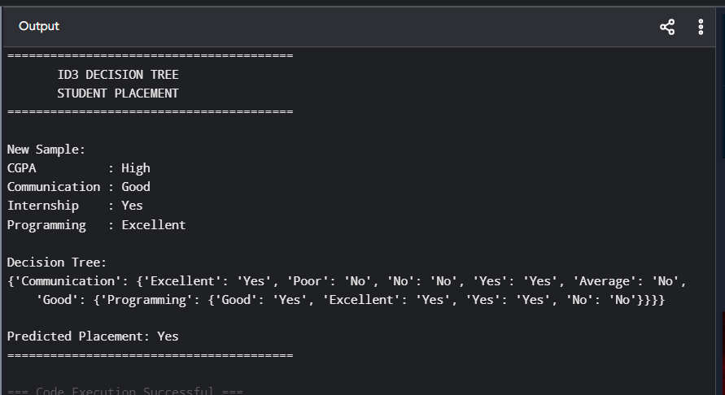

Dataset 3: Loan Approval
Income | Credit Score | Employment | Property | Loan Approved
High | Good | Permanent | Yes | Yes
High | Good | Permanent | No | Yes
Medium | Good | Permanent | Yes | Yes
Low | Poor | Temporary | No | No
Medium | Average | Permanent | No | Yes
High | Average | Temporary | Yes | No
Low | Poor | Temporary | Yes | No
Medium | Good | Permanent | Yes | Yes
High | Good | Permanent | Yes | Yes
Low | Average | Temporary | No | No
Target Variable: Loan Approved
New Sample for Prediction
Income | Credit Score | Employment | Property
Medium | Good | Permanent | Yes
Coding:
# ============================================================
# ID3 Decision Tree - Loan Approval
# Pure Python Version
# No sklearn required
# ============================================================

import math

# ------------------------------------------------------------
# Training Dataset
# ------------------------------------------------------------

X = [
['High', 'Good', 'Permanent', 'Yes'],
['High', 'Good', 'Permanent', 'No'],
['Medium', 'Good', 'Permanent', 'Yes'],
['Low', 'Poor', 'Temporary', 'No'],
['Medium', 'Average', 'Permanent', 'No'],
['High', 'Average', 'Temporary', 'Yes'],
['Low', 'Poor', 'Temporary', 'Yes'],
['Medium', 'Good', 'Permanent', 'Yes'],
['High', 'Good', 'Permanent', 'Yes'],
['Low', 'Average', 'Temporary', 'No']
]

# Target values
y = [
'Yes', 'Yes', 'Yes', 'No', 'Yes',
'No', 'No', 'Yes', 'Yes', 'No'
]

# Feature names
features = [
'Income',
'Credit Score',
'Employment',
'Property'
]

# ------------------------------------------------------------
# Combine X and y
# ------------------------------------------------------------

data = []

for i in range(len(X)):
data.append(X[i] + [y[i]])

# ------------------------------------------------------------
# Entropy
# ------------------------------------------------------------

def entropy(rows):

total = len(rows)

yes_count = 0
no_count = 0

for row in rows:

if row[-1] == 'Yes':
yes_count += 1
else:
no_count += 1

result = 0

if yes_count > 0:

p_yes = yes_count / total

result -= p_yes * math.log2(p_yes)

if no_count > 0:

p_no = no_count / total

result -= p_no * math.log2(p_no)

return result

# ------------------------------------------------------------
# Information Gain
# ------------------------------------------------------------

def information_gain(rows, index):

total_entropy = entropy(rows)

values = set()

for row in rows:
values.add(row[index])

weighted_entropy = 0

for value in values:

subset = []

for row in rows:

if row[index] == value:
subset.append(row)

weight = len(subset) / len(rows)

weighted_entropy += (
weight * entropy(subset)
)

return total_entropy - weighted_entropy

# ------------------------------------------------------------
# Find Best Attribute
# ------------------------------------------------------------

def find_best_attribute(rows, available_features):

best_index = available_features[0]

best_gain = information_gain(
rows,
best_index
)

for index in available_features[1:]:

gain = information_gain(
rows,
index
)

if gain > best_gain:

best_gain = gain
best_index = index

return best_index

# ------------------------------------------------------------
# Build ID3 Decision Tree
# ------------------------------------------------------------

def build_tree(rows, available_features):

labels = []

for row in rows:
labels.append(row[-1])

# All Yes
if labels.count('Yes') == len(labels):
return 'Yes'

# All No
if labels.count('No') == len(labels):
return 'No'

# No attributes left
if len(available_features) == 0:

if labels.count('Yes') >= labels.count('No'):
return 'Yes'
else:
return 'No'

# Select best attribute
best_index = find_best_attribute(
rows,
available_features
)

best_feature = features[best_index]

tree = {
best_feature: {}
}

# Get possible values
values = set()

for row in rows:
values.add(row[best_index])

# Remove selected attribute
remaining_features = []

for index in available_features:

if index != best_index:
remaining_features.append(index)

# Create branches
for value in values:

subset = []

for row in rows:

if row[best_index] == value:
subset.append(row)

tree[best_feature][value] = build_tree(
subset,
remaining_features
)

return tree

# ------------------------------------------------------------
# Build Decision Tree
# ------------------------------------------------------------

available_features = [0, 1, 2, 3]

tree = build_tree(
data,
available_features
)

# ------------------------------------------------------------
# Prediction Function
# ------------------------------------------------------------

def predict(tree, sample):

# If leaf node
if not isinstance(tree, dict):
return tree

# Get attribute
attribute = list(tree.keys())[0]

# Get feature index
index = features.index(attribute)

# Get sample value
value = sample[index]

# Get branches
branches = tree[attribute]

# Follow correct branch
if value in branches:

return predict(
branches[value],
sample
)

return "Unknown"

# ------------------------------------------------------------
# New Sample
# ------------------------------------------------------------
new_sample = [
'Medium',
'Good',
'Permanent',
'Yes'
]

# ------------------------------------------------------------
# Prediction
# ------------------------------------------------------------

prediction = predict(
tree,
new_sample
)

# ------------------------------------------------------------
# Display Result
# ------------------------------------------------------------

print("========================================")
print(" ID3 DECISION TREE")
print(" LOAN APPROVAL")
print("========================================")

print("\nNew Sample:")
print("Income :", new_sample[0])
print("Credit Score :", new_sample[1])
print("Employment :", new_sample[2])
print("Property :", new_sample[3])

print("\nDecision Tree:")
print(tree)
print("\nPredicted Loan Approval:", prediction)
print("========================================")
Output:
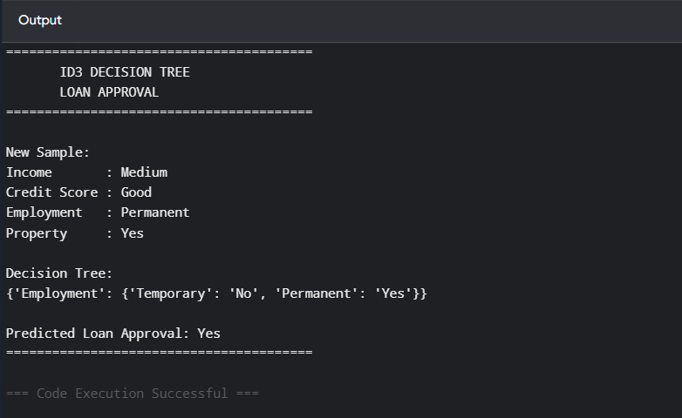
Dataset 4: Disease Diagnosis
Fever | Cough | Headache | Body Pain | Disease
Yes | Yes | Yes | Yes | Positive
Yes | Yes | No | Yes | Positive
No | Yes | Yes | No | Negative
Yes | No | Yes | Yes | Positive
No | No | No | No | Negative
Yes | Yes | Yes | No | Positive
No | Yes | No | Yes | Negative
Yes | No | No | Yes | Positive
Yes | Yes | Yes | Yes | Positive
No | No | Yes | No | Negative
Target Variable: Disease
New Sample for Prediction
Fever | Cough | Headache | Body Pain
Yes | Yes | No | Yes

Coding:
# ============================================================
# ID3 Decision Tree - Disease Diagnosis
# Pure Python Version
# No sklearn required
# ============================================================

import math

# ------------------------------------------------------------
# Training Dataset
# ------------------------------------------------------------

X = [
['Yes', 'Yes', 'Yes', 'Yes'],
['Yes', 'Yes', 'No', 'Yes'],
['No', 'Yes', 'Yes', 'No'],
['Yes', 'No', 'Yes', 'Yes'],
['No', 'No', 'No', 'No'],
['Yes', 'Yes', 'Yes', 'No'],
['No', 'Yes', 'No', 'Yes'],
['Yes', 'No', 'No', 'Yes'],
['Yes', 'Yes', 'Yes', 'Yes'],
['No', 'No', 'Yes', 'No']
]

# Target values
y = [
'Positive',
'Positive',
'Negative',
'Positive',
'Negative',
'Positive',
'Negative',
'Positive',
'Positive',
'Negative'
]

# Feature names
features = [
'Fever',
'Cough',
'Headache',
'Body Pain'
]

# ------------------------------------------------------------
# Combine X and y
# ------------------------------------------------------------

data = []

for i in range(len(X)):
data.append(X[i] + [y[i]])

# ------------------------------------------------------------
# Entropy Function
# ------------------------------------------------------------

def entropy(rows):

total = len(rows)

positive_count = 0
negative_count = 0

for row in rows:

if row[-1] == 'Positive':
positive_count += 1
else:
negative_count += 1

result = 0

if positive_count > 0:

p_positive = positive_count / total

result -= p_positive * math.log2(p_positive)

if negative_count > 0:

p_negative = negative_count / total

result -= p_negative * math.log2(p_negative)

return result

# ------------------------------------------------------------
# Information Gain Function
# ------------------------------------------------------------

def information_gain(rows, index):

total_entropy = entropy(rows)

values = set()

for row in rows:
values.add(row[index])

weighted_entropy = 0

for value in values:

subset = []

for row in rows:

if row[index] == value:
subset.append(row)

weight = len(subset) / len(rows)

weighted_entropy += (
weight * entropy(subset)
)

return total_entropy - weighted_entropy

# ------------------------------------------------------------
# Find Best Attribute
# ------------------------------------------------------------

def find_best_attribute(rows, available_features):

best_index = available_features[0]

best_gain = information_gain(
rows,
best_index
)

for index in available_features[1:]:

gain = information_gain(
rows,
index
)

if gain > best_gain:

best_gain = gain
best_index = index

return best_index

# ------------------------------------------------------------
# Build ID3 Decision Tree
# ------------------------------------------------------------

def build_tree(rows, available_features):

labels = []

for row in rows:
labels.append(row[-1])

# All Positive
if labels.count('Positive') == len(labels):
return 'Positive'

# All Negative
if labels.count('Negative') == len(labels):
return 'Negative'

# No attributes remaining
if len(available_features) == 0:

if labels.count('Positive') >= labels.count('Negative'):
return 'Positive'
else:
return 'Negative'

# Find best attribute
best_index = find_best_attribute(
rows,
available_features
)

best_feature = features[best_index]

tree = {
best_feature: {}
}

# Get values of best attribute
values = set()

for row in rows:
values.add(row[best_index])

# Remove selected attribute
remaining_features = []

for index in available_features:

if index != best_index:
remaining_features.append(index)

# Create branches
for value in values:

subset = []

for row in rows:

if row[best_index] == value:
subset.append(row)

tree[best_feature][value] = build_tree(
subset,
remaining_features
)

return tree

# ------------------------------------------------------------
# Build Decision Tree
# ------------------------------------------------------------

available_features = [0, 1, 2, 3]

tree = build_tree(
data,
available_features
)

# ------------------------------------------------------------
# Prediction Function
# ------------------------------------------------------------

def predict(tree, sample):

# If leaf node
if not isinstance(tree, dict):
return tree

# Get current attribute
attribute = list(tree.keys())[0]

# Get feature index
index = features.index(attribute)

# Get sample value
value = sample[index]

# Get branches
branches = tree[attribute]

# Follow correct branch
if value in branches:

return predict(
branches[value],
sample
)

return "Unknown"

# ------------------------------------------------------------
# New Sample
# ------------------------------------------------------------

new_sample = [
'Yes',
'Yes',
'No',
'Yes'
]

# ------------------------------------------------------------
# Prediction
# ------------------------------------------------------------

prediction = predict(
tree,
new_sample
)

# ------------------------------------------------------------
# Display Result
# ------------------------------------------------------------

print("========================================")
print(" ID3 DECISION TREE")
print(" DISEASE DIAGNOSIS")
print("========================================")

print("\nNew Sample:")
print("Fever :", new_sample[0])
print("Cough :", new_sample[1])
print("Headache :", new_sample[2])
print("Body Pain :", new_sample[3])
print("\nDecision Tree:")
print(tree)
print("\nPredicted Disease:", prediction)
print("========================================")
Output:
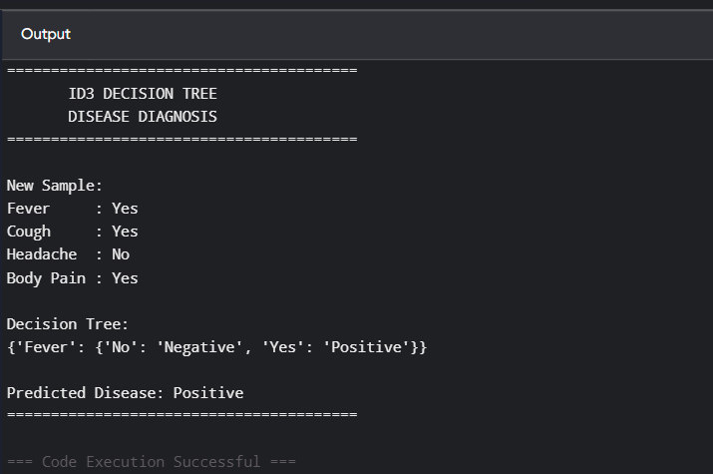
Dataset 5: Employee Promotion
Experience | Performance | Leadership | Training | Promotion
High | Excellent | Yes | Yes | Yes
High | Good | Yes | Yes | Yes
Medium | Good | No | Yes | Yes
Low | Average | No | No | No
Medium | Excellent | Yes | Yes | Yes
Low | Poor | No | No | No
High | Good | Yes | No | Yes
Medium | Average | No | Yes | No
High | Excellent | Yes | Yes | Yes
Low | Poor | No | Yes | No
Target Variable: Promotion
Coding:
# ============================================================
# ID3 Decision Tree - Employee Promotion
# Pure Python Version
# No sklearn required
# ============================================================

import math

# ------------------------------------------------------------
# Training Dataset
# ------------------------------------------------------------

X = [
['High', 'Excellent', 'Yes', 'Yes'],
['High', 'Good', 'Yes', 'Yes'],
['Medium', 'Good', 'No', 'Yes'],
['Low', 'Average', 'No', 'No'],
['Medium', 'Excellent', 'Yes', 'Yes'],
['Low', 'Poor', 'No', 'No'],
['High', 'Good', 'Yes', 'No'],
['Medium', 'Average', 'No', 'Yes'],
['High', 'Excellent', 'Yes', 'Yes'],
['Low', 'Poor', 'No', 'Yes']
]

# Target values
y = [
'Yes',
'Yes',
'Yes',
'No',
'Yes',
'No',
'Yes',
'No',
'Yes',
'No'
]

# Feature names
features = [
'Experience',
'Performance',
'Leadership',
'Training'
]

# ------------------------------------------------------------
# Combine X and y
# ------------------------------------------------------------

data = []

for i in range(len(X)):
data.append(X[i] + [y[i]])

# ------------------------------------------------------------
# Entropy Function
# ------------------------------------------------------------

def entropy(rows):

total = len(rows)

yes_count = 0
no_count = 0

for row in rows:

if row[-1] == 'Yes':
yes_count += 1
else:
no_count += 1

result = 0

if yes_count > 0:

p_yes = yes_count / total

result -= p_yes * math.log2(p_yes)

if no_count > 0:

p_no = no_count / total

result -= p_no * math.log2(p_no)

return result

# ------------------------------------------------------------
# Information Gain Function
# ------------------------------------------------------------

def information_gain(rows, index):

total_entropy = entropy(rows)

values = set()

for row in rows:
values.add(row[index])

weighted_entropy = 0

for value in values:

subset = []

for row in rows:

if row[index] == value:
subset.append(row)

weight = len(subset) / len(rows)

weighted_entropy += (
weight * entropy(subset)
)

return total_entropy - weighted_entropy

# ------------------------------------------------------------
# Find Best Attribute
# ------------------------------------------------------------

def find_best_attribute(rows, available_features):

best_index = available_features[0]

best_gain = information_gain(
rows,
best_index
)

for index in available_features[1:]:

gain = information_gain(
rows,
index
)

if gain > best_gain:

best_gain = gain
best_index = index

return best_index

# ------------------------------------------------------------
# Build ID3 Decision Tree
# ------------------------------------------------------------

def build_tree(rows, available_features):

labels = []

for row in rows:
labels.append(row[-1])

# All Yes
if labels.count('Yes') == len(labels):
return 'Yes'

# All No
if labels.count('No') == len(labels):
return 'No'

# No attributes remaining
if len(available_features) == 0:

if labels.count('Yes') >= labels.count('No'):
return 'Yes'
else:
return 'No'

# Find best attribute
best_index = find_best_attribute(
rows,
available_features
)

best_feature = features[best_index]

tree = {
best_feature: {}
}

# Get values of best attribute
values = set()

for row in rows:
values.add(row[best_index])

# Remove selected attribute
remaining_features = []

for index in available_features:

if index != best_index:
remaining_features.append(index)

# Create branches
for value in values:

subset = []

for row in rows:

if row[best_index] == value:
subset.append(row)

tree[best_feature][value] = build_tree(
subset,
remaining_features
)

return tree

# ------------------------------------------------------------
# Build Decision Tree
# ------------------------------------------------------------

available_features = [0, 1, 2, 3]

tree = build_tree(
data,
available_features
)

# ------------------------------------------------------------
# Prediction Function
# ------------------------------------------------------------

def predict(tree, sample):

# If leaf node
if not isinstance(tree, dict):
return tree

# Get current attribute
attribute = list(tree.keys())[0]

# Get feature index
index = features.index(attribute)

# Get sample value
value = sample[index]

# Get branches
branches = tree[attribute]

# Follow correct branch
if value in branches:

return predict(
branches[value],
sample
)

return "Unknown"

# ------------------------------------------------------------
# New Sample
# ------------------------------------------------------------

new_sample = [
'Medium',
'Good',
'Yes',
'Yes'
]

# ------------------------------------------------------------
# Prediction
# ------------------------------------------------------------

prediction = predict(
tree,
new_sample
)

# ------------------------------------------------------------
# Display Result
# ------------------------------------------------------------

print("========================================")
print(" ID3 DECISION TREE")
print(" EMPLOYEE PROMOTION")
print("========================================")
print("\nNew Sample:")
print("Experience :", new_sample[0])
print("Performance :", new_sample[1])
print("Leadership :", new_sample[2])
print("Training :", new_sample[3])
print("\nDecision Tree:")
print(tree)
print("\nPredicted Promotion:", prediction)
print("========================================")
Output:
